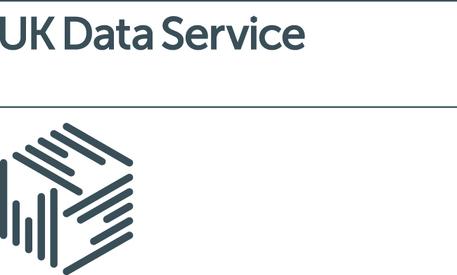
Case Study Submission
The UK Data Service is keen to know how the data we hold is used by researchers and to highlight research excellence to our service users, partners and stakeholders.
If you have developed research which uses data held by the UK Data Service we would like to highlight your work in our collection of case studies. We promote the case studies on our website, in our print publications and publicity, and in training and development sessions for other researchers.
To submit a case study please complete the details below and return it to the Communications and Impact Team at comms@ukdataservice..ac.uk The team can help you write-up your case study and you will receive a copy to check before we publish and promote it. Please include your contact email so we can get in touch if we need more information about your research; your email will not be shared. Please do not include any confidential or commercially sensitive information in your case study.

About you and your project
Name:

Institution and Department:

Position:

Contact email:

Who funded your research?

Funder:

Project Title:

Funding Amount:

Project collaborators, academic
Name:

Institution and Department:

Name:

Institution and Department:

Name:

Institution and Department:

Project collaborators, non-academic
Name:

Organisation:

Name:

Organisation:

Name:

Organisation:

About the research
What was the research question you identified?

Please describe your methodology:

What did your findings show?

Was the research interdisciplinary and if so, which additional subject areas were included?

What UK Data Service datasets or data collections did you use? (Please include the name and edition)

Impact and Engagement
Who did you engage with your research findings? (Other researchers, industry, public sector, the general public?)

Did your research lead to the development of any resources such as websites, guides, policies or other products? Please include any links here:

Did your research receive any media coverage? If it did, please provide links.

Please describe any additional impact your research has had:

What were your research outputs? (Include any significant outputs such as peer-reviewed publications, books, monographs, further funding received)

Additional information
If you would like to include any photographs, illustrations, graphs or diagrams that will help others understand your work, please attach these in a JPEG, Word or PowerPoint format to your submission.

Thank you for taking the time to submit a case study. If you would like to discuss your case study with the Communications and Impact team please do contact us.

Communications and Impact Team
UK Data Service
+44 (0) 1206 872016
comms@ukdataservice.ac.uk

