Reflections on our recent workshop on research transparency and data management for undergraduate students at the University of Essex
The UK Data Service’s Scott Summers – Senior Research Data Services Officer – and Maureen Haaker – Senior Officer of Collections Development – visited an undergraduate Sociology class at University of Essex on 30 January to share some advice and guidance on data management for students preparing to undertake their dissertations. Attendees were second-year university students who had just finished a module on research methods and were starting to look forward toward starting their Dissertation module. The session aimed to get students thinking about some of the practicalities of their data collection and how they can demonstrate rigorous and transparent research.
Even the most experienced researchers know how messy research can get, making data management a key skill to instate from the start of any project. Dissertation puts the strain on students to manage a project while also finishing their degree – making data management all the more vital. Beyond staying on top of the data and meeting deadlines, there is also a real advantage to producing material which can help encourage constructive conversations about data collection and data analysis with supervisors. While this session covered basic data management skills, it also stressed how a clearly documented data management plan can help to help raise the standard of their dissertation work, authenticate all of the work done, and produce a better thesis.
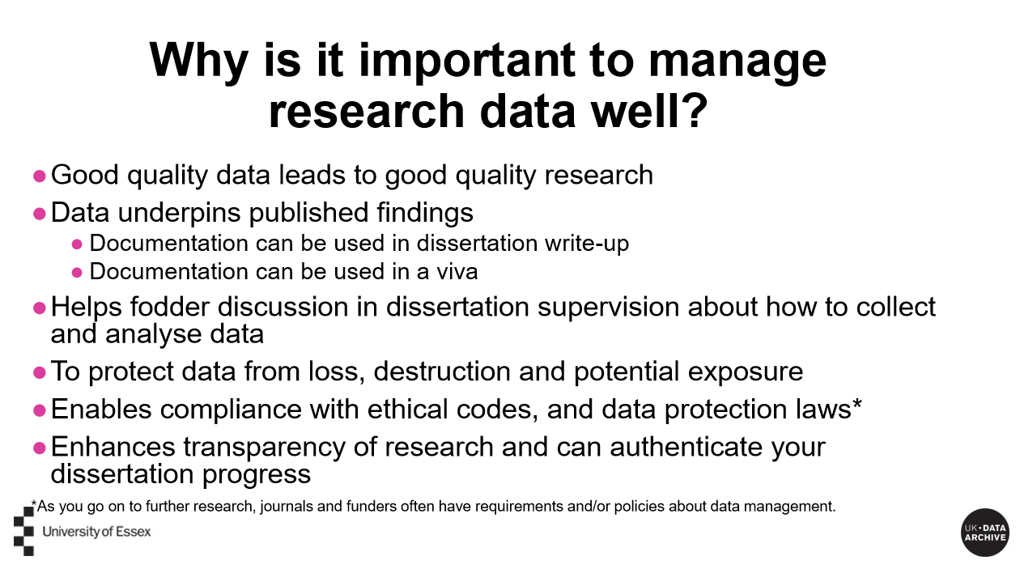
The presentation was divided into five areas which reflects key areas of the ESRC’s principles for data management:
- Assessing data
- Gaining consent
- Anonymising data
- Documenting data
- Formatting, storing and protecting data
Students were also given a booklet with: example documentation, including a model consent form, anonymisation plan and data list, examples of an interview transcript and transcriber’s instructions, and, of course, a data management checklist. All of this material was adapted to the specific needs of the undergraduate students, and included considerations such as sharing anonymised data with supervisors and storing data on university computers.
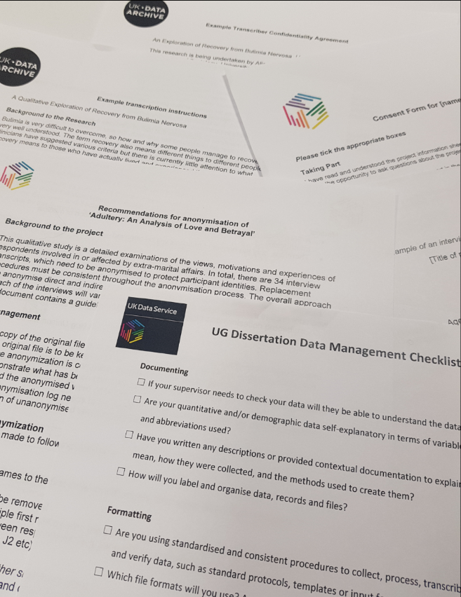
The presentation was brought to life by anecdotes of working with data at the UK Data Service. Scott, for example, shared lessons from his own personal experience of working with data, which included admitting having to spend 2 days defragging a backup because he had not checked to ensure the backups were in good, working condition.
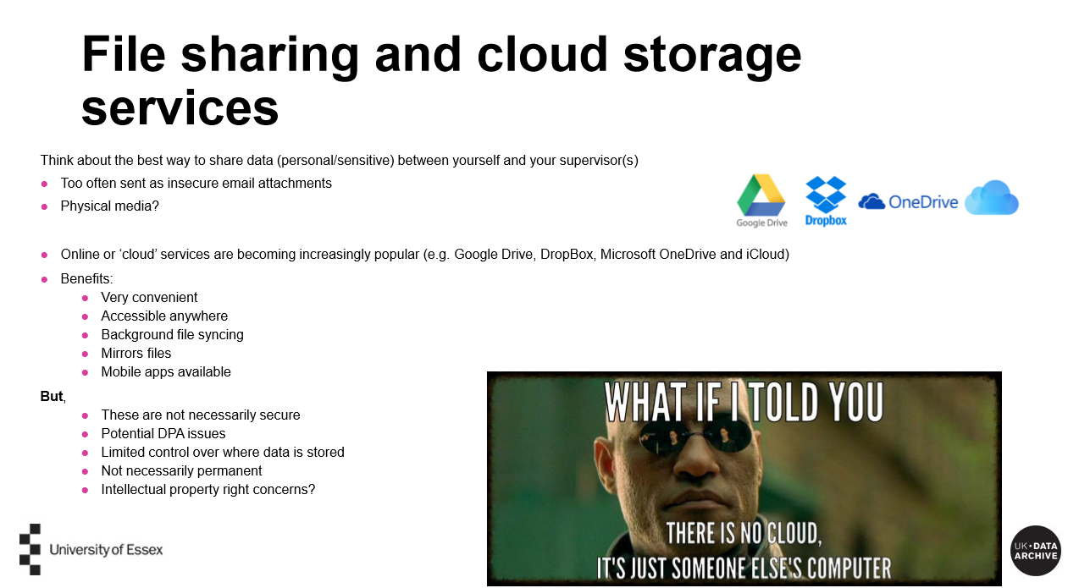
Similarly, Maureen also described the varying quality of interview transcripts she had worked with, and how turn-taking and speaker tags can make a big difference to analysis. Students were really engaged, and asked a lot of specific, well-articulated questions after the presentation. Anna Sergi, the lecturer for the module, said, “Thanks very much for your lecture today, much appreciated and I thought it was very clear and comprehensive.”
The UK Data Service is able to advise on appropriate data management across all levels of study and research and are keen to engage with staff and students and share our expertise of data management. If you think a similar workshop would benefit your students, please get in touch with the UK Data Service on support@ukdataservice.ac.uk.

